

IST/INTERCHANGE CLEARING
TECHICAL OVERVIEW

Oasis Technology Ltd.

© 2002 Oasis Technology Ltd. All Rights Reserved.

This publication was produced by Oasis Technology Ltd.

Oasis Technology Ltd., Client Services
90 Sheppard Avenue East, Suite 100
North York, Ontario
M2N 7B3
Canada

© 2002 Oasis Technology Ltd. All Rights Reserved.

IST is a trademark of Oasis Technology Ltd. Other brand or product names are trademarks or registered trademarks of their respective holders.

The information contained herein is the property of Oasis Technology Ltd. Except as specifically authorized in writing by Oasis Technology Ltd., the holder of this document shall: i) keep all information contained herein confidential, and ii) protect the information, in whole or in part, from disclosure and dissemination to all third parties.

This document, as well as the software described in it, is furnished under license and may only be used or copied in accordance with the terms of such license

Printed in Canada

Document Change Record

Date | Author | Version | Change Reference
Sept 23, 2003 | Jelena Ivanisevic | Version 1.0 | General Update
July 18, 2002 | Haldun Atacan | Draft 2 | Technical Update
Feb. 1 | Wei Cai | Draft 1 | FR, Import, Clearing, Export Update

TABLE OF CONTENTS
1 REFERENCES 7
2 INTRODUCTION 8
2.1 Product Functionality 8
2.2 Transaction Types 9
3 TECHNICAL STANDARDS 10
4 ARCHITECTURE AND COMPONENTS 11
5 The Import Process 12
5.1 Scheduler 12
5.2 File Recognition 14
5.2.1 File Recognition Processing 14
5.2.2 File Recognition Criteria 15
5.2.3 Duplicate Checking 15
5.3 Import Process Universal Agent (UA) 16
5.4 File Control Table 16
6 The Main Clearing Process 18
6.1 Merchant Enrichment 20
6.2 TRANSACTION ROUTING and BIN ENRICHMENT 21
6.2.1 Transaction Direction Flag 24
6.2.2 BIN Model and Clearing Profile 25
6.2.3 Transaction Routing Examples 27
6.3 TRANSACTION VALIDATION AND EDITING 30
6.4 Fee Qualification Module 31
6.5 Acquirer Reference Number (ARN) Generation 33
6.6 TRANSACTION LOGGING 34
7 The Export Process 37
7.1 Scheduler 38
7.2 Export UA Adaptor 38
7.3 File Processing Granularity 39
8 ERROR HANDLING 41
8.1 Import UA Error handling 42
8.2 Error Handling in Clearing Validation 43
8.3 Transaction/File/Batch Suspension Conditions 44
8.4 Suspended Transaction Processing 45
9 APPENDICES 46
9.1 APPENDIX A – ARN Formats 46
9.1.1 Visa ARN 46
9.1.2 MasterCard ARN 47
9.1.3 Item Number 48
9.1.4 American Express ARN 48
9.1.5 Discover ARN 48
9.2 Appendix B: A File Export Criteria SQL Statement 49
9.3 Appendix C: Clearing Services Transaction Flow (UNDER CONSTRUCTION) 50
9.4 Appendix D: Example of TASKS table 53
9.5 Appendix E: Transaction Editing Examples 54
9.6 Appendix F: Sample Transaction Qualification 57
9.6.1 Attribute Table Entries 57
9.6.2 Attribute_Value Table Entries 58
9.6.3 Parameter Table Entries 59
9.6.4 Parameter_Value Table Entries 59

Table of Figures

Figure 1-1 References 7
Figure 2-1 IST/Interchange Clearing System Diagram 9
Figure 4-1 IST/Clearing processing flow 11
Figure 5-1 System control flow and data flow 13
Figure 5-2 File Recognition Processing Example 14
Figure 5-3 In_file_control table update 17
Figure 6-1 Clearing Service Flow for Merchant Capture Transactions 18
Figure 6-2 Clearing Transaction Flow 21
Figure 6-3 Direction Flag of TID 24
Figure 6-4 BIN Module ERD 26
Figure 6-5: Qualification Data Model Hierarchical View 30
Figure 6-6 Qualification Data Model 31
Figure 6-7 Tvs Message Data Model 34
Figure 6-8 File and Batch Control Data Model 36
Figure 7-1 File Export Flow 37
Figure 7-2 File Creation Example 38
Figure 7-3 File Processing Granularity ERD 39
Figure 7-4 Tables Used by Export Process 40
Figure 8-1 Error Level Definition 42
Figure 8-2 Validation Processing 43

REFERENCES

Figure 1-1 References
[UA] | Agent Subsystem Guide (an10d720)
[OVM] | Oasis Virtual Machine (OVM) Subsystem Guide (ov10r720)
[DB] | Database Manager (DMB) Subsystem Guide (df18r720)
[MBOX] | Mailbox Subsystem Guide (mp23r720)
[GUI]
[Table Reference Guide]. | IST/Interchange Table Reference Guide 1.2
[Suspended Transactions] | BRA Business Requirements Analysis, Clearing Service – Suspended Transactions Processing, Version 1.0, July 19, 2002.
[Edits] | BRA Business Requirements Analysis, Clearing Service – Edits, Version 1.0

INTRODUCTION

The purpose of this document is to provide a high level technical overview of IST/Interchange
Clearing.

Product Functionality

IST/Interchange Clearing provides the following main functionality:

- Import of electronic, merchant transaction formatted capture files

- Transaction editing
  - Performs necessary validation of incoming merchant files.
  - Transactions that fail the edit criteria are rejected with an appropriate reason code.

- Transaction qualification and enrichment for reimbursement programs
  - Qualifies transactions according to association rules.
  - Supports International and U.S. Acquiring Interchange Rate Programs.
  - Inserts appropriate Interchange Rate Indicator.

- Acquirer Reference Number (ARN) generation
  - Includes all formats specified by Card Associations.

- Generation of files for various card associations and business entities
  - Ensure valid destination at the transaction level.
  - Creates files in accordance with defined file formats and clearing values.

- Processing of incoming files from Card Associations
  - IST/Interchange Clearing accepts and logs the number and amount of accepted transactions from the incoming settlement files. Incoming Association files may include some or all of the following - settlement records, reclassification advices, returns, fees and chargebacks.

- Interfaces with EMS (Exception Management System)
  - Exception Items: Chargebacks, Returned Items, Funds Disbursements, Fee Collections can be exported to EMS system for further follow up and resolution. Resolved items to be cleared can be imported from EMS and cleared to Card Associations. Reclassification advices are normally directly routed to IST/MAS for processing.

- Interfaces with IST/MAS
  - Generates a file of merchant deposit transactions with the required Interchange Rate Program identifiers, translated into the equivalent MAS code.
  - Sends this file to IST/MAS for processing.

The diagram below illustrates the system entities that interface directly or indirectly with IST/Interchange Clearing.

Figure 2-2 IST/Interchange Clearing System Diagram
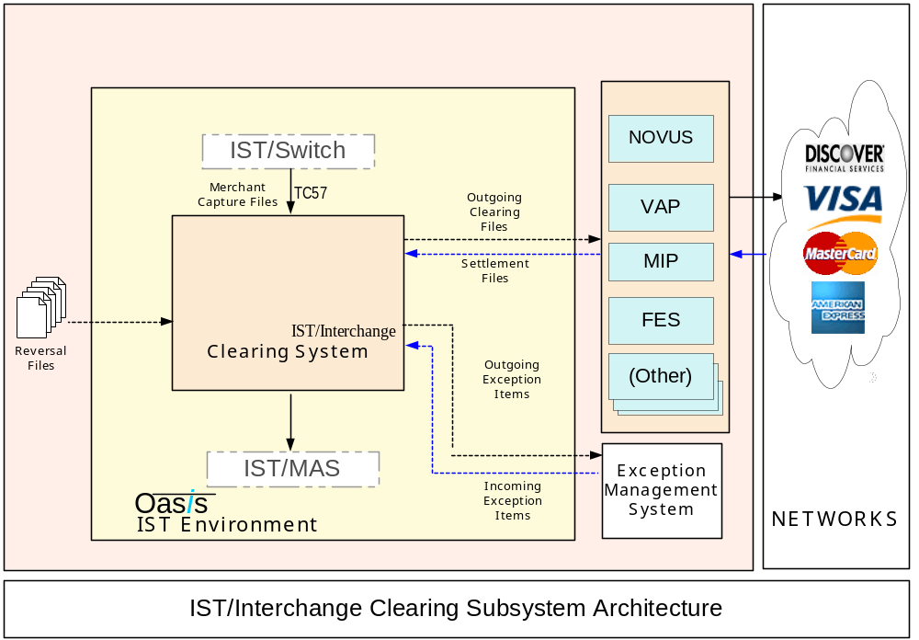

Transaction Types

Clearing Services will support the following transaction types:
- Presentments (including First and Second Presentments, Presentments Reversals, Returned Presentments)
- Chargebacks (including Chargeback Reversals, Returned Chargeback)
- Fees and Charges
- Retrievals (including all subtypes of Retrieval transactions)
- Text messages
- Currency Rate Updates (These messages can come together with other clearing transactions inside the clearing incoming file. (For example ECCF and INET incoming files). These messages (transactions) are not going to be validated as other clearing transactions, but instead the Currency Conversions Module will be invoked that will perform required currency rate updates.
- Reconciliation messages (all messages that don’t need to be cleared will be logged in the database for reporting purposes)
- File and batch headers and trailers (only to be logged, since they don’t need to be exported)
- Note: BIN Updates are provided as a standalone utility that performs BIN table update based on a separate incoming file from Card Association.

TECHNICAL STANDARDS

IST/Interchange Clearing Product architecture complies with IST standard architectural postulates, as follows:
- Universal Agent [UA]
- OVM TMAP [OVM]
- Transaction Vocabulary Service [TVS]
- Logging TVS to Database [TVS_DB]
- IST mailbox environment [MBOX]
- IST Foundation language and utilities [Foundation]
- ELF message processing [ELF]
- GUI standards [GUI]
- Universal Data Model [UDM]

ARCHITECTURE AND COMPONENTS

The processing flow consists of three major processes:

- The Import Process

The Import Process operates according to configured times defined through the Scheduler. It performs file recognition, file integrity and duplicate checking, syntax checking and conversion to internal message format for further processing.

- The Main Clearing Process

Transactions from Import Process are individually validated and enriched with needed information for appropriate clearing destination. The Main Clearing process also performs transaction routing, transaction qualification as well as ARN generation according to the Card Associations rules. All the transactions are logged into the Clearing database tables.

- The Export Processing
Driven by Scheduler, the Export Process create the output files by retrieving data from the Clearing database tables.

Figure 4-3 IST/Clearing processing flow
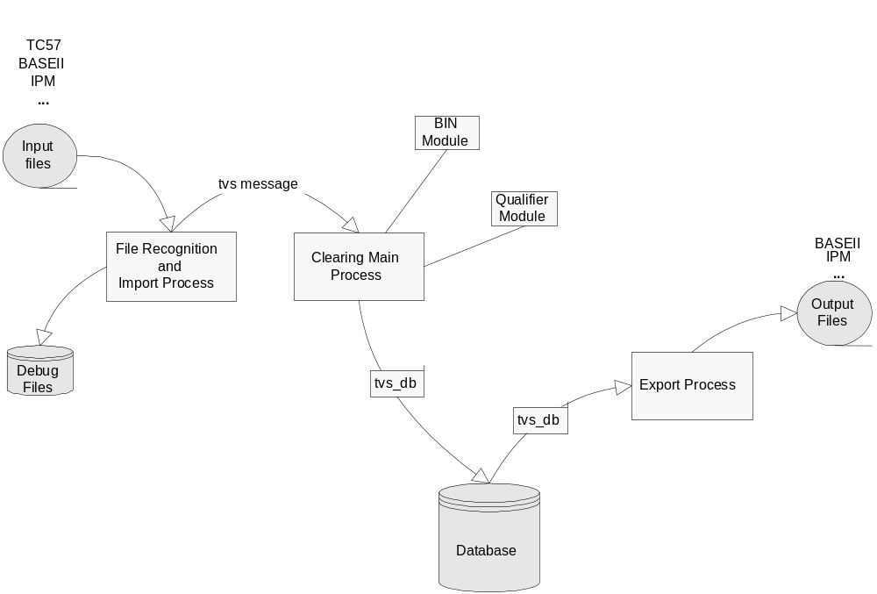

The Import Process

Import Process can import and relay Clearing messages from various sources.

- Merchant Deposit Capture files imported via TC57 file format
- Inbound clearing and settlement files from Card Associations: Visa BaseII, IPM, American Express, etc.

The Import Process involves three components:

- Scheduler (Section 5.1)
- File Recognition (Section 5.2)
- Import Process Universal Agent (UA) (Section 5.3)

The Scheduler instructs the File Recognition task to scan the input file directories at specified periods. File Recognition does the physical integrity, file type and duplicate checking. And then, proper Import UA adaptors are called to provide basic syntax editing and conversion to appropriate TVS message. The TVS messages of the transactions are sent to Main Clearing Process for further processing.

Scheduler

The Scheduler process is configured to run 24*7, scans through a task list in a loop and, according to that list, send start instruction to File Recognition task (through OVM mailbox) to start the appropriate processes.

The configuration for Scheduler is the TASKS table. For each task number, there is a time defined to invoke a task. The import task list example is as follows:

BaseII Import start
BaseII Import stop
IPM Import start
IPM Import stop
Amex Import start
Amex Import stop
All import start
All import stop

Full list of tasks is defined in the TASK_CMD_LIST table. Please refer to example of TASKS table in Section 9.4.

For more details on the TASKS and TASK_CMD_LIST table refer to IST/Interchange Table Reference Guide 1.2 (pg. 109,110).

Scheduler invokes a File Scan Task of File Recognition task for each file type. The File Scan Task scans the predefined directory (defined in the INST_FILE_TYPE table), and if there are incoming files to be processed, copies the file to the “..\processing” directory and sends a message to the File Recognition process to invoke file recognition processing.

Figure 5-4 System control flow and data flow

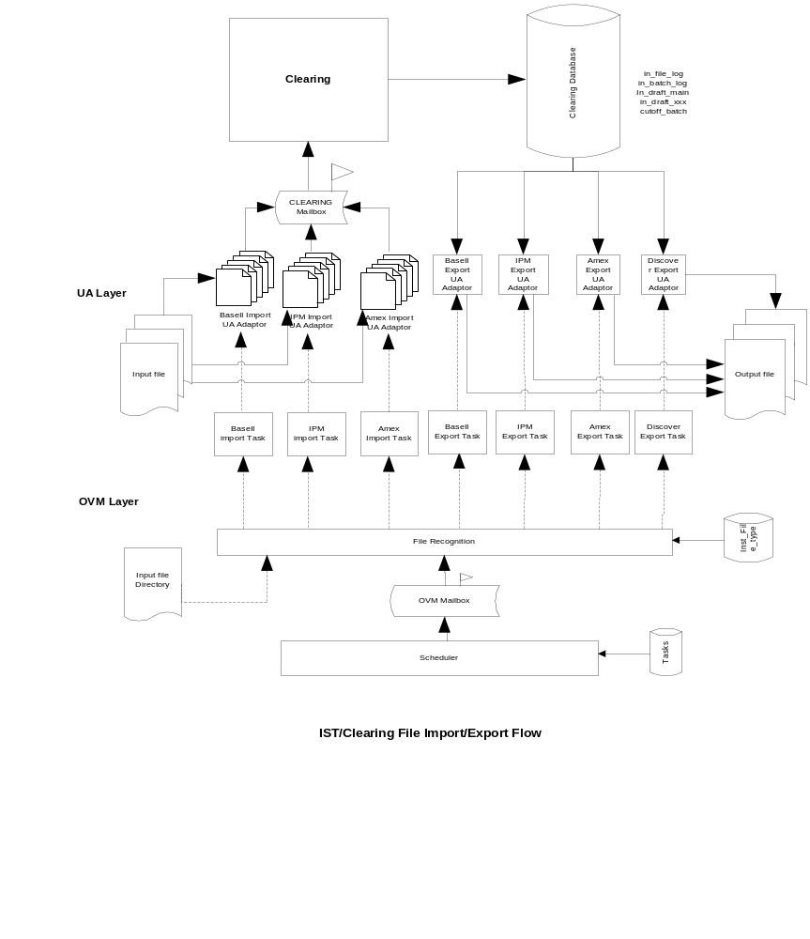

File Recognition

File Recognition Processing

The main function of File Recognition is to recognize the files from different sources (Section 5.1.2.2) and check for duplicate files (Section 5.1.2.3). The unique unprocessed files are to be processed by the proper UA adapters invoked by File Recognition.

The number of File Recognition processes that can work simultaneously will depend on the number of incoming files that should be processed and the general scaling of the system. The maxim limit of the number of the File Recognition process is defined in OVM configuration file apm.src.

Input_file_manager is part of the File Recognition Task.

The following diagram illustrates an example where the IPM and BASE II files are to be processed in a predefined daily timeframe.

Figure 5-5 File Recognition Processing Example
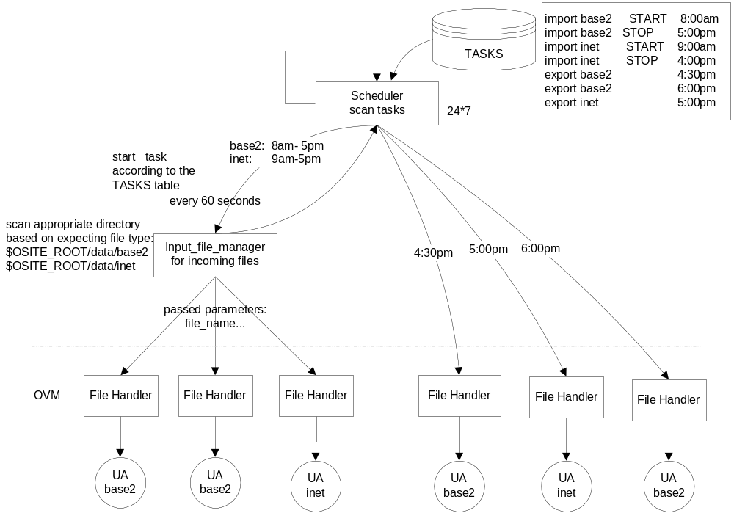

Input File Manager1 of the File Recognition will be invoked by the Scheduler every 60 seconds (if it is not already active). If there is nothing to process, the control will be returned to the Scheduler. If there are, for example, 10 files to be processed, the files will be moved to the “..\processing” directory, and one by one, will be processed by three available File Recognition processes. The number of the File Recognition Tasks is defined in the OVM configuration file apm.scr. The remaining incoming files will wait for another cycle. If after 60 seconds, the Input File Manager1 is still active, the new cycle will be skipped. Once all the files from the first cycle are processed, the Input File Manager stops, the control is returned to the Scheduler and the Input File Manager1 will be invoked again by the Scheduler in the next cycle.

Important note: The File Recognition Process begins as soon as files appear on the predefined directories providing the time of appearance falls into a predefined processing window.

File Recognition Criteria

File types are defined in the table FILE_TYPE. Table INST_FILE_TYPE has for each file source institution and file type defined directories, file name masks as well as UA Adaptors used to process this file type. For more information, refer to IST/Interchange Table Reference Guide 1.2 (pg. 61-63).

The way to recognize a file type is by its file name using predetermined file name masks. An example of a file name mask would be:

$10I.IPM.$4J.$3S

$10I – first (up to) 10 characters source institution id.
IPM – word ‘IPM’ appears in the file name after the first ‘.’
determining the file type
$4J - Julian date in 4 places after the second ‘.’
$3S – sequence number

File source institution id and file type will be recognized by the file name. Since different source institutions can create their files with the same file name mask, there should be a descriptor in the file name that IST/Interchange Clearing can recognize (e.g. ‘IPM’ for IPM files, or BASEII for Base II files).

The external utility responsible for the ‘file transfer’ can rename the file at the point when the file is transferred to the Clearing system. For example, it can add source institution and file type to the determined position in the file name.

Once the file type is identified by file name, File Recognition can process the file according to the configuration file and in_out flag defined in table INST_FILE_TYPE.

Duplicate Checking

Duplicate file checking is performed for each incoming file to ensure the file has not already been processed. A file is considered duplicate if it comes with the same filename. All incoming files will be logged in the IN_FILE_CONTROL table. The external file name of the incoming file will be compared with the already imported and successfully processed files (using the IN_FILE_CONTROL table – external file name and corresponding status).

If a match is found, the file is rejected as duplicate and an entry is logged in the IN_FILE_CONTROL table, with the status ‘0’ (duplicate file).

Import Process Universal Agent (UA)

The UA adapter in the Import Process provides basic syntax editing, including data type mapping and checksum controls. No business or multi-field edits are performed. It translates the transaction into the TVS Canonical Clearing Message (CCM) format. UA will create the TID based on the transaction and add it into TVS Canonical Clearing message for Main Clearing Process to do the further processing.

One of the major tasks in the Import Process is recognizing headers and trailers, as well as, the reconciliation messages. Also, these types of records need to be logged to a database for future reference.

Furthermore, the Import Process needs to create a canonical file header and a canonical file trailer for each file. A canonical batch header and a canonical batch trailer also need to be created for each batch within the same file. These canonical messages will be in TVS format as well, which the Clearing Services will use to identify the end-of-batch or the end-of-file.

Transactions are sent one by one (file, batch headers and trailers, financial and non-financial transactions with addenda) in the TVS message format to the Main Clearing Process.

If an Import UA finds errors during syntax checking, data type mapping or checksum controls, it will generate error codes and insert error data into the clearing message. Once the processing of a message is complete, clearing message will be sent to the Main Clearing process. The details of UA Error Handling are explained in Section 8.

File Control Table

The IN_FILE_CONTROL Table is used to track status of a file during the Import Process, as well as during Main Clearing processing.

All recognized files are logged in this table. The Import process inserts a record, with the external file name and processing date and time, on each new incoming file. This record is updated with the appropriate status and error code, if applicable, during further processing. A report of successfully processed files, duplicate files and rejected files that need to be resubmitted and reprocessed, can be obtained from this table.

Once the file in the “../processing” directory have been processed, the file is moved to directory “../done”.

Figure 5-6 In_file_control table update
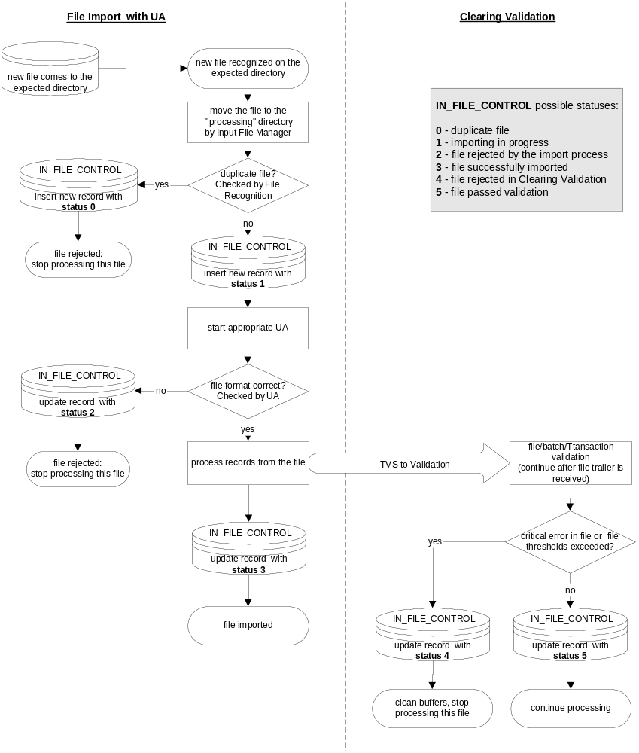

The Main Clearing Process

The Main Clearing process receives transactions one by one, in TVS message format, from the Import UA process.

Actions taken on each transaction processing is mainly determined by the TID (Transaction Identifier). TIDs used by IST/Clearing represent normalized set of values that will uniquely identify a transaction i.e. First Presentment is always the same code regardless of the Card Association code used for this transaction. Please refer to transaction codes in [Table Reference Guide]. Batch and File headers and trailers also have own TIDs.

The following table shows the most complex flow in the system – Merchant Capture Transaction Flow. All other transactions would have only some but not all of the steps shown in this table. Comprehensive list of steps for all transactions is shown in Section 9.3.

Figure 6-7 Clearing Service Flow for Merchant Capture Transactions
Clearing Service Flow for Transactions Incoming from the Merchant System, POS Service Providers, or any Merchant Data Capture System
Step | Regular Flow | Exceptions
Incoming File Characteristics:
- Transaction Acquirer – Transaction Source Institution
- File Type/Format – File Source Institution

1 | Transaction Basic Validation  Following fields are validated:  - Merchant Id  - PAN and PAN check digit  - Transaction amount  - Purchase date  - Transaction Acquirer | After the basic validation is completed, if one or more errors are reported:  - Transaction is declared not valid for further processing and it will be suspended  - CS continues with the next transaction
2 | CES : Core Entity Service (Transaction Routing and BIN Enrichment)  - Source Determination/Enrichment  - Destination Determination/Enrichment  - Clearing Profile | After the CES module processing is completed, if one or more errors are detected and reported during the execution:  - Transaction is declared not valid for further processing and it will be suspended  - CS continues with the next transaction
3 | Merchant Enrichment  - Transaction enrichment with relevant merchant attributes from UDM Merchant/Acquiring Entity DB  - Configurable as force enrichment, enrich only missing fields or do not enrich. At the moment configured in TRANS_EDITOR table (may be changed in near future) | If one or more errors are detected and reported during the execution, after the Merchant Enrichment function completing:  - Transaction is declared not valid for further processing and it will be suspended  - CS continues with the next transaction

4 | Transaction Validation and Enrichment  Required validation functions will be performed as configured in the Qualification Model (EDIT Subsystem)  This model also allows enrichment of transactions based under Qualified Conditions. | If one or more required validation rules are not satisfied:  - Corresponding errors are reported  - CS continues with the transaction processing
5 | Transaction Qualificaton  (Perform Only if Card Scheme is 04 – Visa, 05 – MasterCard and 06 – Europay)  - Transaction Pre-Qualification Enrichment  - TGA, Number of Clearing Days  - Qualification IRF Subsystem Determination  - Transaction IRF Qualification  - Configured using Qualification Data Model (used for Fee Qualifications, Editing, and Enrichment). | - Validation must be performed as a basic validation.  - Errors will not be reported in this stage  - Transaction editing later will enrich the transaction against the IRF program transaction was qualified for.
6 | ARN Generation  (Perform Only if Card Scheme is 04 – Visa, 05 – MasterCard and 06 – Europay) | - Validation must be performed as a basic validation.  - Errors will not be reported in this stage  - ARN will be generated and assigned to the transaction.
7 | MAS Code Assignment  (Perform only if Primary or Secondary Destination is MAS – 21) | - In case that there is no corresponding entry in MAS_CODE_CLEARING table, MAS Code Default Value if configured will be assigned.  - Default MAS Codes are defined within Card Schemas and on Global Level.
8 | Transaction Post Editing and Enrichment  Required editing functions will be performed as configured in EDIT Subsystem of the Qualification Model. | - Editing functions will enrich the transaction.  - Example: Put “Original Ticket Number” in positions 13 to 25 of Merchant Name if transaction is qualified for CPS/passenger Transport PSIRF and if the Base 2 format will be used as clearing.  - “Informative” or “Warnings” error severity levels can play very important role here.
9 | Error Thresholds checking
10 | Transaction Logging (2. pass)

Merchant Enrichment

IST/Clearing enriches transactions with merchant information in order to provide:
- Correct outgoing formats for all card associations;
- The best fee qualification.

At this point, merchant enrichment functionality is used only on the incoming transactions from the Merchant System, POS Service Providers, or any Merchant Data Capture System. Please refer to Flow 7 of the Transaction Routing diagram. Other flows do not support merchant enrichment.

Merchant Enrichment depends mainly on the following parameters:
- Transaction Source Institution – POS Service Provider, Merchant Data Capture System, or Acquirer system may have different processing system and capabilities.
- Source file type/ format – source institutions may have more than one file type/format, and some of them may not be reliable.
- Destination file type/format – different destinations dictate different requirements.

To facilitate different level of enrichment depending on the data availability from different sources of merchant transactions, IST/Clearing provides three types of enrichment:
- Full enrichment – IST/Clearing database is used for all merchant data
- Enrichment for missing information – IST/Clearing only enriches data missing in the transaction
- No enrichment – IST/Clearing does not perform any enrichment. This will optimize the processing for transaction sources that do not require any enrichment.

The following is Merchant Information that will be enriched by IST/Clearing:
- Standard Merchant Description (e.g. DBA Name, City, State, etc.)
- Corporate/Purchasing specific Merchant Description (e.g. Merchant Tax ID, Alternate Tax ID)
- Visa MPS Specific - TC50 Merchant registration – (e.g. MPS Registration Number, Ownership Change Date, Out of Business Date)
- Merchant Numbers (e.g. Amex Establishment Number, CDC Service Establishment Number)
- Additional registration flags or indicators: Program Registration Information, Merchant Volume Indicator

Tables used for enrichment are:
- ACQ_ENTITY – Most of the information required for enrichment is stored in this table (e.g. Standard Description, Corporate/Purchasing Description, Registration flags )
- ALT_MERCHANT_ID – Merchant Numbers
- ALLOWANCE, ALLW_MCC – MCC information
- ACQ_ENTITY_CONTACT, MASTER_CONTACT – MPS Owner Information
- ACQ_ENTITY_ADDRESS, MASTER_ADDRESS – Address information, phone numbers

For more information on fields available for enrichment as well as table definitions, refer to IST/Interchange Table Reference Guide 1.2(pg.93-104).

TRANSACTION ROUTING and BIN ENRICHMENT

IST/Clearing has a comprehensive, configurable transaction routing process. This section first outlines possible transaction flows that IST/Clearing supports and further explains the implementation of those flows using BIN Data Model and Clearing Profile Data Model.

Figure 6-8 Clearing Transaction Flow
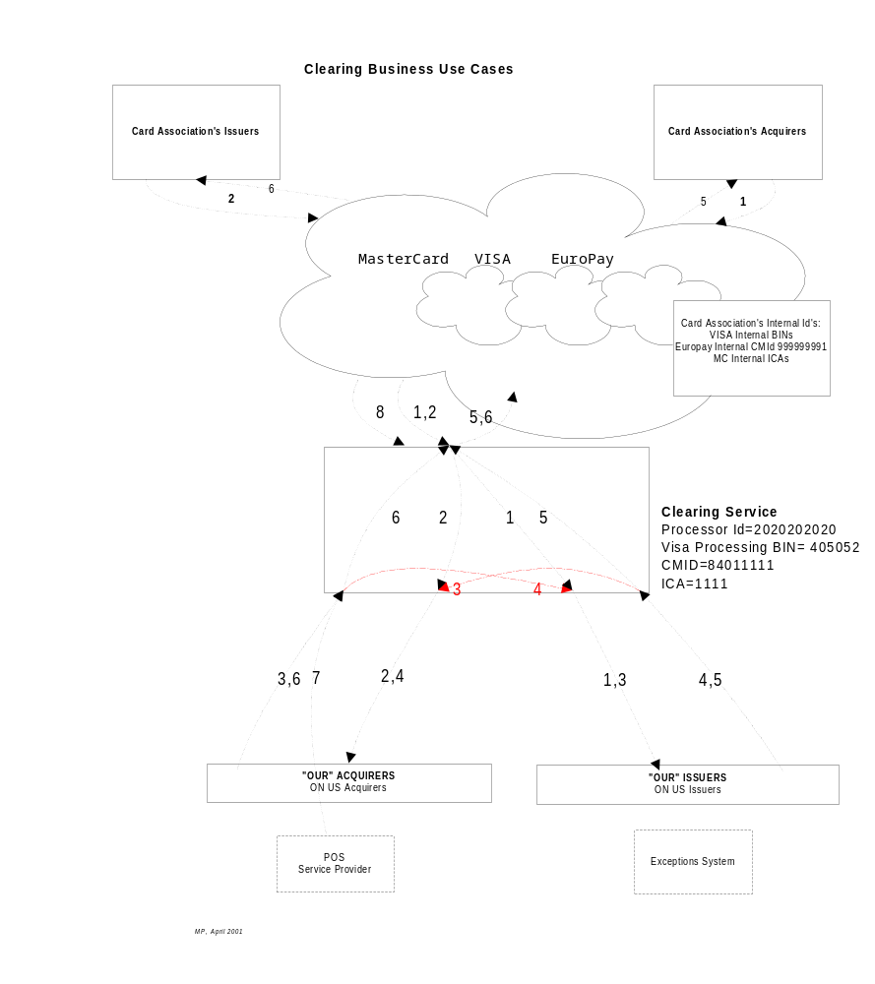

Transaction Flows shown in the diagram above:

- Card Association → ON US Issuers
Actors: Card Association (External Acquirers), ON US Issuers
Format:
- Incoming: Card Association dependent: VISA BASE II, MasterCard INET or IPM, Europay ECCF
- Outgoing: Processor, Client, and Exception System Dependent – OCS
Transaction Types:
- Presentments, Second Presentments, Reversals
- Retrieval Requests
- Fees/Funds,
- Administrative messages

2. Card Association → ON US Acquirers (“OUR” Acquirers, Internal Acquirers)
Actors: Card Association (External Issuers), ON US Acquirers
Format:
- Incoming: Card Association dependent: VISA BASE II, MasterCard INET or IPM, Europay ECCF
- Outgoing: Processor, Client, and Exception System Dependent – OCS
Transaction Types:
- Chargebacks, Second Chargebacks
- Retrieval Requests Responses
- Fees/Funds,
- Administrative messages

3. “OUR” Acquirers → “OUR” Issuers
This business case is a special instance when acquirer and issuer have an agreement to clear their transactions without the Card Association.
Actors: Internal (ON US) Acquirers, Internal (ON US) Issuers
Format:
- Incoming: Processor, Client Data Capture System Dependent
- Outgoing: Processor, Client Dependent
Transaction Types:
- Presentments, Second Presentments, Reversals
- Retrieval Requests
- Fees/Funds
- Administrative Messages

4. “OUR” Issuers → ON US Acquirers (“OUR” Acquirers, Internal Acquirers)
This business case is a special instance when acquirer and issuers have an agreement to clear their transactions without the Card Association.
Actors: Internal (ON US) Issuers, Internal (ON US) Acquirers
Format:
- Incoming: Processor, Client, and Exception System Dependent
- Outgoing: Processor, Client Dependent
Transaction Types:
- Chargebacks, Second Chargebacks
- Retrieval Requests Responses
- Fees/Funds,
- Administrative messages

5. “OUR” (Internal) Issuers → Card Association (OF US Issuer’s Transactions)
This business case is a general OF US issuer’s transactions clearing.
Actors: Internal (ON US) Issuers, Card Association
Format:
- Incoming: Processor, Client, and Exception System Dependent
- Outgoing: Card Association dependent: VISA BASE II, MasterCard INET or IPM, Europay ECCF, Amex, Discover
Transaction Types:
- Chargebacks, Second Chargebacks
- Retrieval Requests Responses
- Fees/Funds,
- Administrative messages

6. “OUR” (Internal) Acquirers → Card Association (OF US Acquirer’s Transactions)
This business case is a general OF US acquirer’s transactions clearing.
Actors: Internal (ON US) Acquirers, Card Association
Format:
- Incoming: Processor, Client, and Exception System Dependent
- Outgoing: Card Association dependent: VISA BASE II, MasterCard INET or IPM, Europay ECCF, Amex, Discover
Transaction Types:
- Presentments, second Presentments, Reversals
- Retrieval Requests
- Fees/Funds,
- Administrative messages

7. Data Capture Transactions
Data Capture, merchant’s transactions, “OUR” Acquirer → Card Association (for OF US or ON US Issuers)
This business case is a special instance of the previous business case where VISA Data Capture format TC 57 is understood.
Actors: Internal (ON US) Acquirers, Card Association, ON US Issuers
Format:
- Incoming: Data Capture Advices VISA BASE II Transactions TC 57
- Outgoing: Card Association dependent: VISA BASE II, MasterCard INET or IPM, Europay ECCF, Amex, Discover
Transaction Types:
- Purchase or Sale
- Return or Credit

8. Card Association → Members
This business case refers to the transactions initiated by the Card Association’s processing or clearing system itself.
Actors: Card Association, ON US Issuers, Acquirers or Processors.
Format:
- Incoming: Card Association dependent: VISA BASE II, MasterCard INET or IPM, Europay ECCF, Amex, Discover
- Outgoing: Processor, Client, and Exception System Dependent
Transaction Types:
- Transactions Returned from Card Association’s processing or Clearing System
- Transactions Rejected from Card Association’s processing or Clearing System
- Transactions with Reclassification Advices from Card Association’s processing or Clearing System
- Transactions for System Update

Transaction Direction Flag

Direction Flags are assigned to each TID to define transaction fields used in transaction Source Determination and Destination Determination.

Figure 6-9 Direction Flag of TID
Domain | Scope | Class | Code | Subtype | Description | Direction  Flag
01 | 01 | 03 | 005 | 000 | All Presentment and Reversals
01 | 01 | 03 | 010 | 000 | All Fees and Fund Disbursement
01 | 01 | 03 | 015 | 000 | All Chargebacks
01 | 01 | 03 | 020 | 000 | Retrieval Request and Reversals
01 | 01 | 03 | 025 | 000 | Retrieval Request Response and Reversals
01 | 01 | 13 | 005 | 000 | All Rejected transactions
01 | 01 | 23 | 005 | 000 | All Returned transactions

Outcome Source and Destination Determination steps are used as key to find transaction primary and secondary destination, corresponding file formats according to the Clearing Profile.

BIN Model and Clearing Profile

The key components of transaction routing and BIN enrichment in IST/Clearing are BIN Data Model and Clearing Profile Data Model. The following briefly explains key tables and their role in the model.

The institution table lists all institutions that are part of the system. The inst_type column identifies the type of a listed institution. Examples include (CARD_ASSOCIATION, MEMBER, etc.). There is only one main_inst in the system that indicates this institution is the licensed owner of Oasis product. There are other types of institutions that take part in the system.

The card_scheme table specifies a list of valid card schemes supported by the system (e.g., AMEX, Visa, MasterCard, Discover and other private label cards).

The mbr_issuer_bin table stores issuing BINs for member banks. From this table it can be identified if a member institution owns a BIN. This is pertinent to processing on-us transaction.

The mbr_alias table is the next table to be setup. There are three uses for this table:
- map an incoming acquirer or forwarding institution ID to our institution ID.
- map our institution ID to that which the institution is known by for the destination.
- map the destination Institution ID to the appropriate network known ID. This would be used for transactions that require a receiving institution ID, such as receiving ID (ISO DE 100).

The BIN table is where all bins are stored. This table is automatically updated with information supplied in incoming files from Card Associations.

The visa_bin_specific, mc_specific tables store additional information related to a given BIN stored in the bin table.

When an acquirer institution searches the bin table and finds two entries with the same bin but from two card associations, the acq_cs_priority table is the point of lookup to determine the priority. A priority (for a card scheme) can indicate the applicable clearing and settlement information to be followed.

Finally, the CLEARING_PROFILE is the key table used for transaction routing. Based on key elements including Source Institution, BIN range, TID, Currency Code, Card Scheme, Receiving Institution, this table provides primary and secondary destination of the transaction as well as enrichment elements for the destination such as Forwarding Institution Id, Acquirer Bin, Acquirer Business Id, etc.

Figure 6-10 BIN Module ERD
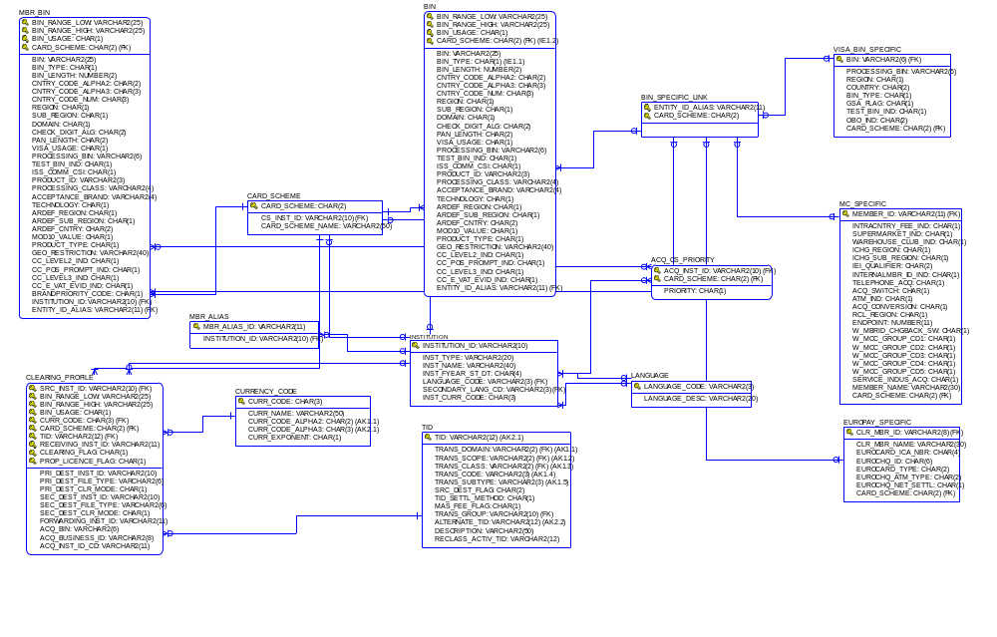

Transaction Routing Examples

To illustrate how the source and destinations are determined and how the transactions are routed internally, the selected cases (Flow 7 and Flow 2 from Figure 6-8 Clearing Transaction Flow) are provided in this section.

Flow 7: Original Transactions

Original transactions to be processed include sales drafts, credit vouchers and manual cash advances. These are Data Capture, merchant transactions that IST/Switch passes to IST/Interchange Clearing in the VISA BASE II Advice File (TC 57/50) format.

The following are the steps taken in the transaction routing and enrichment processes:

File Source Institution Determination:

File Source Institution Id is Draft Capture Service Provider institution and can be found from the file name directly or file recognition process. This Institution Id is File Source and is used for all error thresholds, all file, batch and transaction logs as Source Institution. This institution can but does not have to be the same as Acquirer Institution.

Source Determination

The Source Institution (Acquirer Institution) is determined in the following way:

Note: In TC57 VISA Standard or OASIS Extended format, Transaction Acquirer is in Destination Bin Field, pos 5 – 1, TCR 0 – Batch Header; Source Bin Field indicates who is the Processor or Data Capture Service Provider.

- If the Acquiring Bin (can be found in the Destination BIN field of TC57 messages) is found in the MBR_ALIAS, this Institution_id is used to determine the Clearing Profile for transaction routing as well additional Acquirer information for the destination in question.

- If the Acquiring BIN/Acquirer ID is not found in the MBR_ALIAS table, an error is reported

Destination Determination

- The PAN is taken from the transaction and searched in the MBR_ISSUER_BIN (This table stores issuing BINs for member banks. From this table it can be identified if a member institution owns a bin.)

  - If the PAN is found in the MBR_ISSUER_BIN (i.e. it falls within the BIN_RANGE_LOW and Bin_RANGE_HIGH), the transaction is initiated with a card issued by ‘internal’ issuer. This is the Destination BIN. The corresponding Card Scheme is also obtained from this table.

  - If the PAN is not found in the MBR_ISSUER_BIN table (i.e. it does not fall within the BIN_RANGE_LOW and Bin_RANGE_HIGH), it is searched in the BIN TABLE (This table stores Ranges coming from the major Card Associations: VISA (ARDEF + BIN Extract tables), (BIN), MasterCard (BIN/ICA – Record Type=0)

  - If the PAN is found in the BIN Table (i.e. it falls within the BIN_RANGE_LOW and Bin_RANGE_HIGH) then the corresponding instance of BIN represents the Destination Bin.
The corresponding Card Scheme is also obtained from this table.

After this determination is done, the next step is to obtain the Clearing Profile.

Clearing Profile

The Clearing Profile is obtained from the CLEARING_PROFILE Table (containing clearing Profiles to “OUR” or “ON_US” members and Clearing profiles for clearing to the Card Associations) in the following manner:

The Clearing profile corresponding to the INSTITUTION_ID from the Source determination, BIN_RANGE_LOW and BIN_RANGE_HIGH (from the Destination determination), BIN_USAGE (corresponding to the applicable BIN range from the MBR_ISSUER_BIN/BIN table), CARD_SCHEME (corresponding to the selected BIN range), CURR_CODE, TID (internal Transaction ID as applicable from the TID table) . and RID(valid values can be ENTITY_ALIAS_ID from the MBR_ALIAS table or Internal Institution ID as determined in the destination institution determination and ‘EXTERNAL’ in case the transaction has to be cleared to the network).

This corresponding instance of CLEARING_PROFILE will represent the enrichment for transaction routing.

Flow 2: Retrieval Requests, Chargebacks and Chargeback Reversals

The following are the steps taken in the transaction routing and enrichment processes:

Source Determination

As the transaction is coming on the file from the Card Association, the UA process provides CARD_SCHEME and SOURCE_INSTITUTION_ID (e.g. VISA, MasterCard) on the file or batch level for all transactions from that file/batch coming from the Card Associations. If this is not the case, the following method is used to determine source.

Destination Determination

The applicable transaction Acquiring ID (VISA = ARN; MasterCard IPM = Transaction Destination Institution ID (DE 093) or Receiving Institution Identification Code – RID (D100) is obtained.

Using RID as an example, the RID is looked up in the MBR_ALIAS table.

If the RID is found in the MBR_ALIAS then the Internal Institution ID corresponding to the MBR_ALIAS_ID is the Destination Institution and the Card Scheme. If the RID is not found in the MBR_ALIAS then the appropriate error is reported.

Clearing Profile

The Clearing profile corresponding to the SOURCE_INSTITUTION_ID (from the Source determination), BIN_RANGE_LOW and BIN_RANGE_HIGH (from the Destination determination, if applicable) BIN_USAGE (corresponding to the applicable BIN range from the MBR _ISSUER_BIN/BIN table, if applicable), CARD_SCHEME (corresponding to the selected BIN range), CURR_CODE corresponding to the source_institution, TID (internal Transaction ID as applicable from the TID table. This Table stores a set of TIDs (Internal Transaction Identifier), used in the system to identify the type of transaction) and RID (valid values can be ENTITY_ALIAS_ID from the MBR_ALIAS table or Internal Institution ID as determined in the destination institution determination and ‘EXTERNAL’ in case the transaction has to be cleared to the network).

This corresponding instance of CLEARING_PROFILE will represent the enrichment for transaction routing.

TRANSACTION VALIDATION AND EDITING

Transaction validation and editing will be done at various steps of the Main Clearing Process as shown in the Clearing Flow table in Section 6:

  - Basic Transaction Validation – a set of non-configurable validation checks performed as the first step and essential for further processing.
  - Transaction Validation and Editing – a set of configurable edit conditions

Sample list of edit functions and associated error codes can be found in [Edits].

Editing is configured using the Qualification Data Model (Section 6.4) as shown in diagram below.

Figure 6-11: Qualification Data Model Hierarchical View
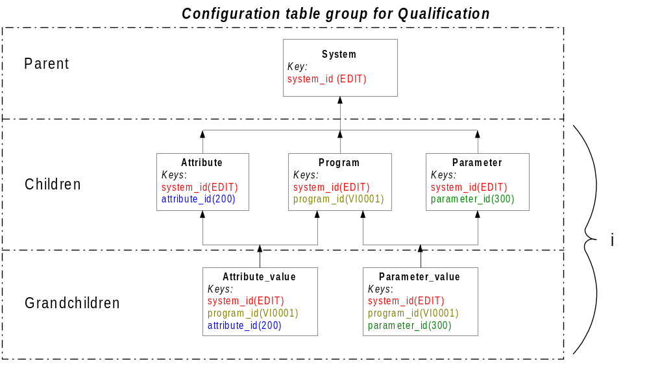 Transaction Editing examples are shown in Section 9.5.

Fee Qualification Module

The following is key functionality provided by IST/Clearing as it relates to Fee Qualification:

  - Transaction Pre-Qualification Enrichment
    - E.g. TGA, Number of Clearing Days
  - Qualification IRF Subsystem Determination
  - Transaction IRF Qualification

The Clearing module qualifies transactions according to Card Association rules. This process validates all requirements for specific Interchange Rate Program qualification. The transaction is assigned and enriched with the appropriate Interchange Rate Indicator.

Every interchange transaction has certain attributes to describe it and to determine the transaction nature. The Interchange Fee Qualification process will examine the transaction attributes against the Interchange Rate Program attributes. This process will validate all requirements that qualify a transaction for a specific Interchange Rate Program and will assign or enrich the transaction with the appropriate Interchange Rate Indicator.

IST/Clearing implements complex transaction fee qualification programs using configuration defined in the Qualification Data Model as shown in Figure 6-12 Qualification Data Model.

Figure 6-12 Qualification Data Model

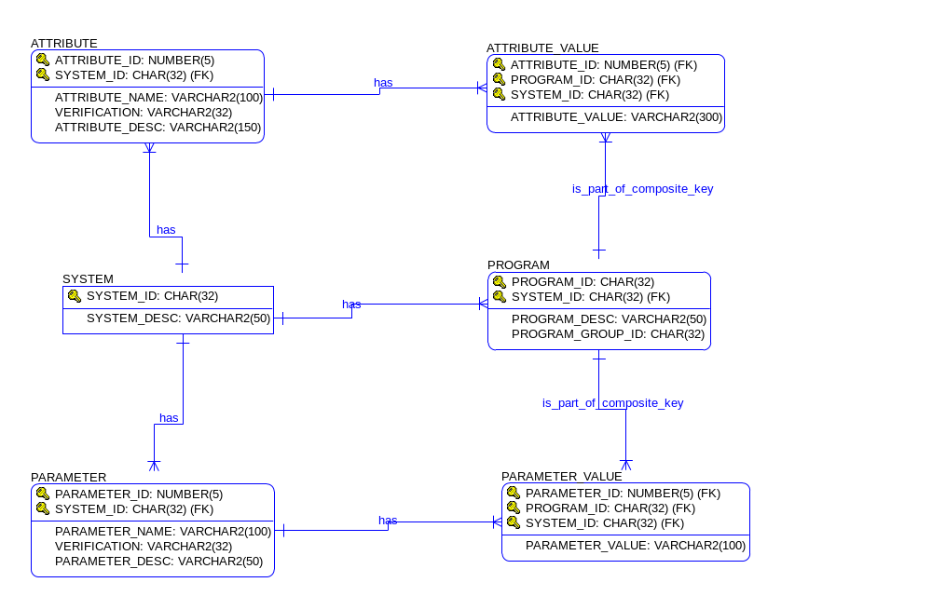

A list of attributes (TVS Fields) is defined for each of the systems e.g. FEEQUAL – Fee Qualification System, EDIT – Editing System. The attributes are defined in the ATTRIBUTE table.

A list of programs is defined within each system (PROGRAM table).

Each program is associated with a set of conditions that need to be met. Conditions are defined as required attribute values for that program in the ATTRIBUTE_VALUE table.

A list of parameters (TVS Fields) is defined within each system (PARAMETER table).

Each program is associated with a set of parameters (TVS Fields) that will be populated with values as specified in the PARAMETER_VALUE table in case all program conditions are met as specified.

Transaction Qualification example is shown in Section 9.6.

This model also facilitates Subsystem Determination functionality by grouping programs into smaller sub-systems using the parent-child organization of programs. This will allow interchange programs to be grouped based on Card Scheme, Transaction Geographical Assignment, Product Type, etc. (for example, MasterCard Domestic Consumer programs). As shown in Figure 6-11, program levels can be repeated to any required depth.

Acquirer Reference Number (ARN) Generation

The ARN Generator module is used to generate the ARN for original transactions, according to Card Association rules. A portion of the ARN is mandated, with the remainder available for discretionary use by the Acquirer.

ARN generation will support the formats specified by:

- Visa
- MasterCard
- American Express
- Discover

Refer to Appendix A for the formats to create ARN for Visa, MasterCard, American Express and Discover.

TRANSACTION LOGGING

Figure 6-13 Tvs Message Data Model
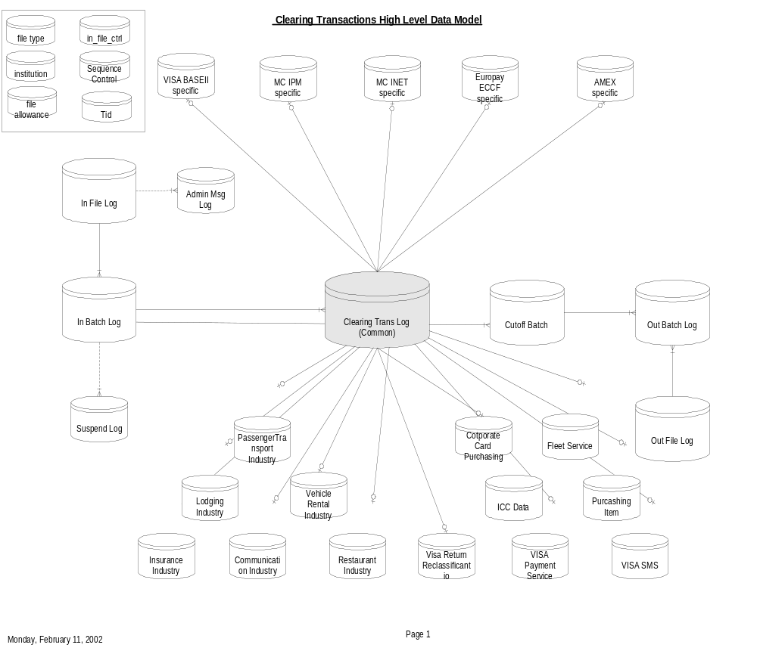

The following logs will be maintained in the database.

- Input File Log: The details of the input files for processing are logged here.

- Input Batch Log: The batch details of the input files are logged here.

- Transaction Log : This is the log where the transaction is recorded in the database. It consists of a Master Log which contains the common data elements for Presentments, Reversals, Retrieval Requests, Retrieval Request Responses, Chargebacks and Fee Collections. The additional data is logged into Association specific logs, Card Product specific and Industry specific logs as show in the figure above.

- Cutoff Batch Log: Links all transactions from an incoming batch prepared to be cleared to the same destination.

- Output File/Out Batch Log: All the details of the output files/batches to various Associations etc are logged here.

- File Error Log: All errors identified in the files for processing are logged here.

- Transaction Error Log/Suspended Transaction Log: The details of transactions that cannot be processed or are suspended due to errors, are logged here.

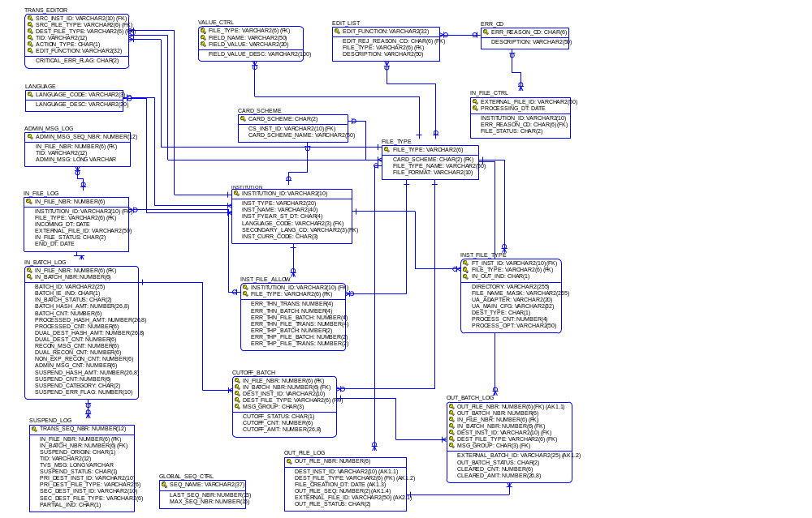

Figure 6-14 File and Batch Control Data Model

The Export Process

The clearing messages will be exported and relayed to their appropriate destinations. Possible destinations include:

- Card Associations, exported via Visa Base II, MasterCard IPM, Amex, Discover or OCS file formats
- Other processing destinations e.g. Exception Management Systems via OCS file format or other specific file format
- IST/MAS, in the IST/MAS input file format, containing the billing and settlement transactions

The Export process will run at a predefined time as per the Scheduler. It will extract the transactions for a given destination (Destination Institution Id) and file type (Destination File Type) from the database (e.g. MasterCard is Destination Institution, IPM is Destination File Type). The Export UA will then convert the transactions into the required formats and write them in the appropriate files in the directories specified for given destinations.

Figure 7-15 File Export Flow
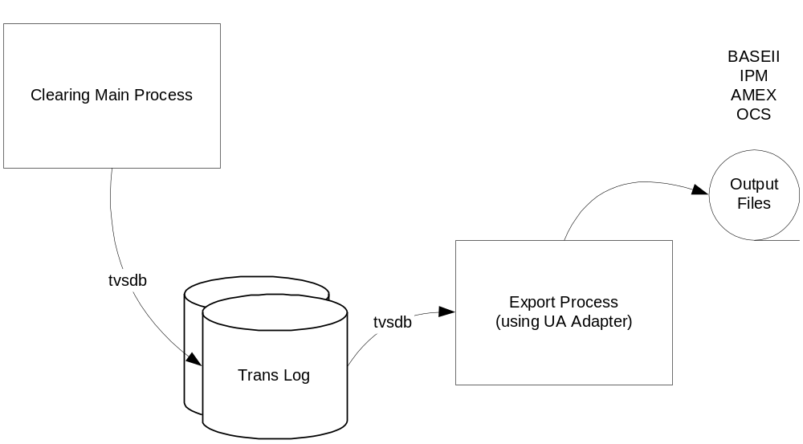
Export Process Processing Flow

Scheduler

An Export process for a certain file type (and destination institution) will be invoked at the predefined time, according to the scheduler, and will finish after the outgoing file is completed. A file creation example is shown in Figure 7-16.

Figure 7-16 File Creation Example
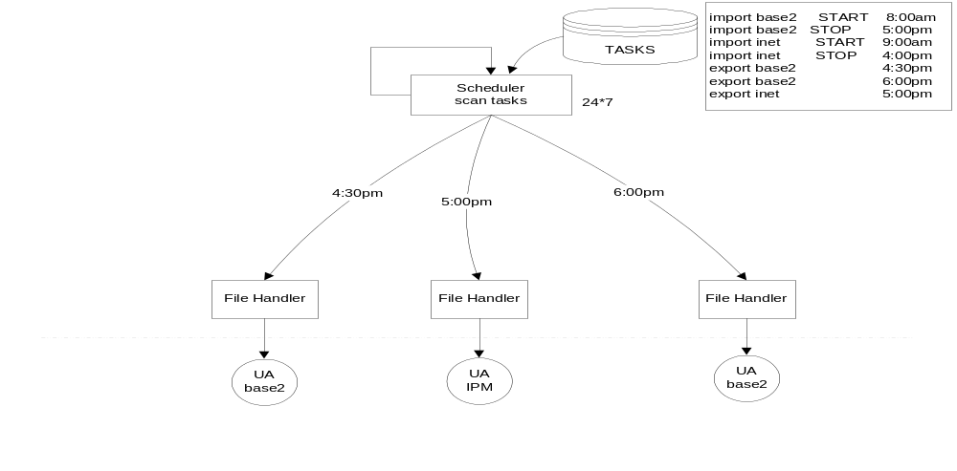

Export UA Adaptor

The Export UA Adaptor creates each output file based on each Destination Institution ID and Destination File Type. They are defined in the UA configuration files.

For each Destination Institution ID and Destination File Type, UA finds the correspondent record from table in_draft_main according to each record of table cutoff_batch. All the records with the cutoff status “C” are to be processed. Then, the TRANS_SEQ_NBR of the in_draft_main table is the key to search each addendum tables (Restaurant, Oil Company, Auto Rental, Lodging, etc.)

The batch and the file details of the outgoing files will be logged in OUT_BATCH_LOG and OUT_FILE respectively.

File Processing Granularity

File Processing Granularity, meaning that transactions from the incoming file cannot be exported until the whole incoming file is processed, will be implemented through Batch Control class that will be used by Clearing process as well as by Export process. At the same time we will have control what transactions are successfully exported without marking them on a transaction level.
Figure 7-17 File Processing Granularity ERD
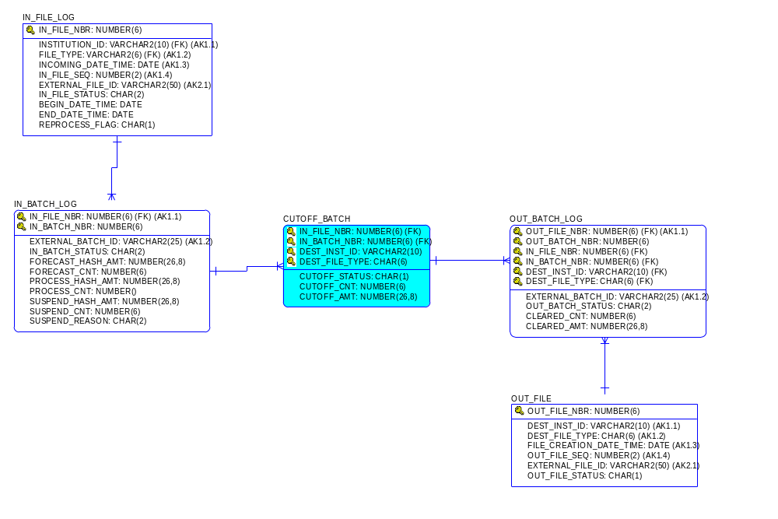

Figure 7-18 Tables Used by Export Process

MAIN/BASIC Tables for all the industries
- CUTOFF_BATCH
  - IN_DRAFT_MAIN
  - IN_DRAFT_AMEX
  - MERCHANT_DESC
    - RESTAURANT_ADN(Restaurant)
    - FLEET_SERV_ADN (Oil Company)
    - VEHICLE_RENTAL_ADN(Auto-Rental)
    - INSURANCE_ADN (Insurance)
    - COMMUNICATION_ADN (Communications Services)
    - LODGING_AND(Lodging)
    - PASSEN_TRAN_ADN (Travel/Cruise industry)
    - PASSEN_TRAN_ADN(Airline)
    - PASSEN_TRAN_TRIP(Airline)

The Tables to be modified (insert/update) after processing
  - CUTOFF_BATCH
  - OUT_FILE_LOG
  - OUT_BATCH_LOG
  - OUT_FILE_SEQ_CTRL

ERROR HANDLING

The following describes some basic terms used in error handling.

Critical error | A transaction with a critical error cannot be processed and cleared. It is declared a non-valid transaction. This transaction will be suspended alone or within a batch (whole batch suspended) or within a file (whole file suspended).
Non-critical error | A transaction with a non-critical error can be processed and cleared. It is still a valid transaction. Only if the number of non-critical errors exceeds the transaction error threshold, is it declared a non-valid transaction. It is then treated as a transaction with a critical error.
Valid batch | A batch with all valid transactions or a batch with a number of non-valid transactions that is below the number or percentage of non valid transactions defined by the batch error threshold.
Non valid batch | A batch where the number of non-valid transactions exceeds the number or percentage of non-valid transactions defined by the batch error threshold.
There are two fields reserved for error ‘reporting’:

- Critical Error Flag
  - I/O flag determining whether the transaction/batch/file contains a critical error
- Number of non-critical errors
  - The total number of non-critical errors in the transaction/batch/file

Problem | Type of error | Error handler action
Card scheme, source and destination BIN determination and enrichment  Edit functions (critical) | Critical | - Mark the transaction as non valid  - Set the appropriate error code  - Increment the counter for critical errors (per batch)  - Continue processing
Edit functions (non critical) | Non-critical | - Increment counter for non-critical errors; the starting counter value for each transaction comes from the UA in the TVS message  - Set the appropriate error code in the TVS message (and the counter value)  - If the counter is above the transaction error threshold, mark the transaction as a non valid transaction  - Continue processing

Import UA Error handling

Errors in IST/Clearing can be encountered in two modules, namely “Importing” and “Clearing” steps. In first step, incoming transactions are checked against syntax and format errors. In the next step, business edits and validations are done. The table below shows errors detected by the Import UAs.

Problem | Level | Type of error | Error handler action
The file cannot be opened,  file header cannot be translated | File | Critical | - Log the file and the reason for abortion in a database table IN_FILE_ERR_LOG  - Move the file to ‘reject’ directory  - No message is sent to Clearing Validation  - Abort further processing of the file in UA
Translation datatype problem (nonessential elements) | Field/ Transaction | Non-critical | - Set null value as the content of the element  - Increment counter for non-critical errors and assign the value to ‘Number of Non-Critical Errors’ in the TVS message  - Continue processing
Translation datatype problem (PAN, transaction amount …)  TID mapping | Field/ Transaction | Critical | - Set null value as the content of the element  - Mark the transaction as non valid transaction (Critical Error Flag in the TVS message set to ‘Y’)  - Continue processing
Batch checksum | Batch | Critical | - Mark the transaction (batch header/trailer) as non valid transaction (Critical Error Flag in the TVS message set to ‘1’)  - Send TVS and Continue processing
File checksum | File | Critical | - Mark the transaction (file header/trailer) as non valid transaction (Critical Error Flag in the TVS message set to ‘1’)  - Send TVS

Figure 8-19 Error Level Definition

Error Handling in Clearing Validation

During the clearing process, errors can occur at different processing steps as shown in Section 6. Sample list of edit functions and associated error codes can be found in [Edits].

The following diagram shows the File/Batch/Transaction Validation processing.
Figure 8-20 Validation Processing
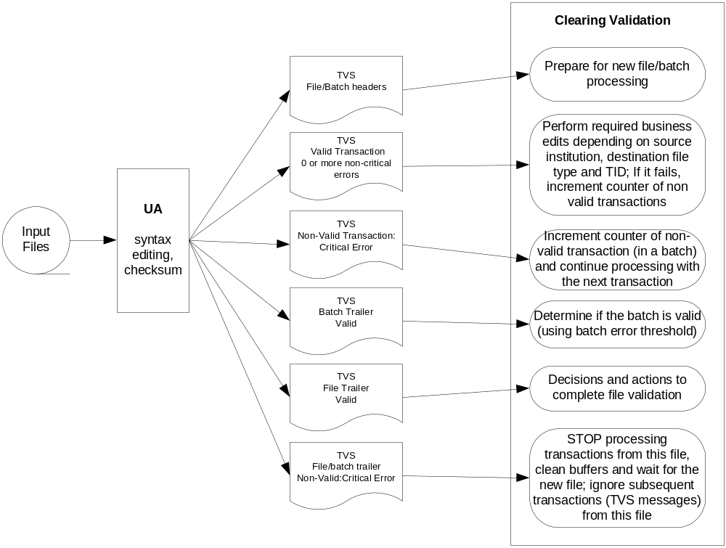

Transaction Validation Workflow

The File Source Institution determined by the file recognition is used to determine error thresholds for the file.
- For each transaction to be cleared a number of required edits must be done. A transaction will be marked as non-valid, with the appropriate error codes, if it fails the validation criteria. A transaction can be valid even if it contains one or more non-critical error codes.
- If the batch trailer is reached and if the batch counter of non-valid transactions is greater than the batch error threshold, this batch is declared a non-valid batch. The process will increment the file counter of non-valid batches.
- If the file trailer is reached and the file counter of non-valid batches is greater than the file error threshold, this file is declared a non-valid file and one of the following steps will be taken:
  - The whole file is suspended OR
  - All non-valid batches are suspended OR
  - All non-valid transactions from valid transactions are suspended while all good transactions are passed through
A new record is inserted in the file and the batch log tables in the database, except in the following case.
If a file/batch trailer is received with a critical error, the Validation process will stop and will ignore further TVS messages from this file. The error will be logged in the IN_FILE_ERR_LOG table, indicating that the file could not be processed. No detail transactions will be saved in the database.

Transaction/File/Batch Suspension Conditions

Single Transaction Suspension

A single transaction will be suspended when:
- One or more critical errors are found in the transaction OR
- The number of non critical errors in the transaction exceeds the transaction error threshold AND the total number of non-valid transactions in a batch does not exceed the batch error threshold OR
- The number of non critical errors in the transaction exceeds the transaction error threshold AND the total number of non-valid batches in a file does not exceed the file error threshold

The following actions occur when a transaction is suspended:
- The failed transaction is stored in the transaction suspend log
- The corresponding batch is updated with the status “Partially Processed Batch”, and the appropriate suspended count and amount are updated in the batch record

Batch Suspension

A batch will be suspended when:
- The total number of non-valid transactions in a batch exceeds the batch error threshold AND
- The total number of non-valid batches in a file does not exceed the file error threshold

The following actions occur when a batch is suspended:
- The batch record is updated with the status “Suspended Batch” and the appropriate suspended count and amount are updated in the batch record
- All transactions from the batch are stored in the transaction suspend log. Failed transactions will contain previously determined reject reason codes

File Suspension

A file will be suspended when:
- The total number of non-valid batches in a file exceeds the file error threshold OR
- The total number of non-valid, non-batched transactions exceeds the error threshold for non-batched transactions OR
- The file/batch trailer is received with a critical error

The following action occurs when a file is suspended:

- The error is logged in the IN_FILE_CONTROL table with the appropriate file status, indicating the file could not be processed
No detail transactions will be saved in the database.

For more information on status codes for file and batch levels, refer to [Table Reference Guide] under IN_FILE_LOG and IN_BATCH_LOG descriptions.

Configuring Threshold Levels in INST_FILE_ALLOW Table

Institution_id | PK | Source institution of the file (Visa, MC…)
File_type | PK | File type e.g. IPM, BaseII, OCS, TC57 ….
Err_threshold_trans |  | Number/percentage of allowed non-critical errors in a transaction
Err_threshold_batch |  | Number/percentage of allowed non valid transactions per batch
Err_threshold_file_B |  | Number/percentage of allowed non valid batches per file
Err_threshold_FILE_T |  | Number/percentage of allowed non valid transactions per file (related to non-batched transactions only)

For more information on the INST_FILE_ALLOW table, refer to [Table Reference Guide].

Suspended Transaction Processing

For more information on Suspended Transaction Processing, refer to [Suspended Transactions].

APPENDICES

APPENDIX A – ARN Formats

Visa ARN

The Acquirer Reference Number is a 23-digit identification number assigned to the record in the
First Presentment. This field must be included in the Base II record for each transaction processing
Cycle. The structure is outlined below:

Field Name | Format | Description
Format Code | N1 | The entry must be either a 2 or a 7.  Purchase representments:  (TC 05, Usage Code=2) must contain a 7.  Purchase chargebacks and reversals:  (TC 15,25 and 35; usage code =1or 2) may contain either a 2 or 7.  Credit vouchers and cash transactions:  (TC 06, 07,16, 17, 26, 27, 36, and 37; Usage Code = 1 or 2) must contain a 7.  National – CPS Participating Countries:  Original purchase transactions:  (TC 05; Usage Code = 1) must contain a 2 in this field.  Purchase representments:  (TC 05, Usage Code = 2) must contain either a 2 or 7.  Note: The Format Code is used to ensure a valid Visa reference number.
BIN | N6 | The entry must be a valid six digit acquiring BIN per the current BIN Table.  May be an issuing BIN for cash disbursements.
Date | N4 | The Date field must contain a four-digit numeric in the format YDDD (year and Julian day). The date should be either the data capture date or the pre-edit program run date.
Film Locator | N11 | The field must contain an 11– digit numeric.  Original Draft Transactions  (TC 05, 06, and 07; usage Code =1) must not be zeros.
Check digit | N1 | The entry must be a valid standard Modulus – 10 check digit of the preceding 22 digits.

MasterCard ARN

The ARN is a 23-digit numeric field that identifies the transaction throughout its life cycle from presentment to retrieval to chargeback and finally to remedy. The 23 digits are constructed as indicated below:

Field Name | Format | Description
Interchange Rate Indicator (IRI)  (Positions 1-2) | N2 | The Interchange Rate Indicator (IRI) is a two-position value that, in combination with the region and sub-region, if defined, identifies the interchange program for which an item is presented. For transactions presented for other than the Standard program, the 5 in the acquirer’s BIN is replaced by a designated value assigned for that interchange rate program. For example:  Merit III = 70 7521700 becomes 7021700  or  80 8521700 becomes 8021700  International Electronic  = 73 7521700 becomes 7321700  or  83 8521700 becomes 8321700  The IRI also may be assigned to programs specific to an industry such as  MasterPhone™ telephone service.
Acquirer’s Bank Identification Number (BIN)  (Positions 2-7) | N5 | The Acquirer BIN, excluding the first digit (left justified, trailing zeroes). The six-position numeric MasterCard BIN is assigned to the acquirer. It is numerically filled as necessary; for example, 5217 becomes 521700 through 521799. (Acquirers may use the extra padded positions as they see fit.)  Note: The first position of the acquiring BIN is overlaid with the second position of the interchange rate indicator.
Julian date  (Positions 8-11) | N4 | A four-position numeric field containing the Julian year and day when the acquirer submits the transaction into interchange. It must be in the form YDDD, with Y as the last digit of the current year and DDD as the Julian date. For example, 1 June 2000, would be expressed as 0153.
Item Sequence Number  (Positions 12-22) | N11 | An 11-position numeric field containing values determined by the acquirer.  Item Sequence Number Guideline Example  The 11 positions of the ARN defined as the item sequence number have primary significance for the acquirer. The acquirer should determine its item sequence number only after it carefully considers the current and future requirements of the retrieval process. The following information should be considered for inclusion within the item sequence number.  Retrieval Format Code  Use of a retrieval format code enables the acquirer to implement new retrieval processes and to discern previous formats.  Microfilm Date  The Julian day the item was microfilmed by the acquirer or by an agent on its behalf.  Document Location  A numeric value assigned by the acquirer denoting the storage location of the original document. This could be an agent bank facility, a merchant providing electronic input of captured items, a POI merchant that retains original documents, or a similar location.  Reel Number  A numeric value representing the reel or canister number where the item is located. It is recommended that values in this field be assigned by the acquirer to differentiate types of transactions such as sales, payments, adjustments, and transferred items.  Item Number  A numeric value representing the film frame number assigned to the individual item.
Check digit  (Position 23) | N1 | A one-position numeric field containing a value determined by using the Luhn Formula Modulus 10 algorithm on the previous 22 positions of the reference number.

American Express ARN

There is no Acquirer Reference Number for American Express.

Discover ARN

There is no Acquirer Reference Number for Discover.

Appendix B: A File Export Criteria SQL Statement

The following is the file export criteria:

QUERY( dest_inst_id varchar2(10), dest_file_type varchar2(6) )
{
WHERE cutoff_batch.dest_inst_id = :dest_inst_id AND
cutoff_batch.dest_file_type = :dest_file_type AND
cutoff_batch.in_file_nbr = in_draft_main.in_file_nbr AND
cutoff_batch.in_batch_nbr = in_draft_main.in_batch_nbr AND
cutoff_batch.dest_inst_id = in_draft_main.pri_dest_inst_id AND
cutoff_batch.dest_file_type = in_draft_main.pri_dest_file_type AND
cutoff_batch.msg_group = 'CCM' AND
cutoff_batch.cutoff_status = 'R'
ORDER BY in_draft_main.in_file_nbr,
in_draft_main.in_batch_nbr,
in_draft_main.trans_seq_nbr;
WHERE in_draft_main.trans_seq_nbr = in_draft_baseii.trans_seq_nbr;
WHERE in_draft_main.trans_seq_nbr = visa_adn.trans_seq_nbr;
WHERE in_draft_main.trans_seq_nbr = lodging_adn.trans_seq_nbr;
WHERE in_draft_main.trans_seq_nbr = vehicle_rental_adn.trans_seq_nbr;
WHERE in_draft_main.trans_seq_nbr = fleet_serv_adn.trans_seq_nbr;
WHERE in_draft_main.trans_seq_nbr = visa_sms_adn.trans_seq_nbr;
WHERE in_draft_main.trans_seq_nbr = visa_pay_serv_adn.trans_seq_nbr;
WHERE in_draft_main.trans_seq_nbr = icc_data.trans_seq_nbr;
WHERE in_draft_main.trans_seq_nbr = passen_tran_adn.trans_seq_nbr;
WHERE in_draft_main.trans_seq_nbr = passen_tran_trip.trans_seq_nbr
ORDER BY passen_tran_trip.trip_leg_key;
}

Appendix C: Clearing Services Transaction Flow (UNDER CONSTRUCTION)
POS Data Capture Transactions to Clearing Service (ACQUIRING)

Transaction type | Basic Validation | Routing determ. | Merchant related data enrichment | Transaction Editing | Fee qual. related data enrichment | Fee Qual | ARN | Currency conversion | Log | Export | Where
TC 57 Data capture advices: transaction types 5,6,7, 8 (*)  VISA Card Initiated | √ | √ | √ |  | √ | √ | √ | C | √ | √ | VISA,  TC 05,06,07, 25, 26, 27 and corresponding addendums ,  TC 50 for commercial Cards  MAS
TC 57 Data capture advices: transaction types 5,6,7, 8 (*)  MasterCard Card Initiated | √ | √ | √ |  | √ | √ | √ | C | √ | √ | MasterCard MTI 1240 with corresponding addendums  MAS
TC 57 Data capture advices: transaction types 5,6,7, 8 (*)  Amex Card Initiated | √ | √ | √ |  |  |  |  |  | √ | √ | Amex,  Record types 05, 06 and corresponding addendums  MAS
TC 57 Data capture advices: transaction types 5,6,7, 8 (*)  Discover Card Initiated | √ | √ | √ |  |  |  |  |  | √ | √ | Discover Novus Network, Record types 05, 06 and corresponding addendums  MAS
Headers, Trailers | √ |  |  |  |  |  |  |  | √
Internally Suspended transactions |  |  |  |  |  |  |  |  | √ (1) |  | Reported

- Suspended transactions log process
C – Conditional
* 5 – purchase or sale; 6 – return or credit; 7 –cash disbursement; 8 – no show for Lodging
0 – Direct Debit Cancel; 3 – Direct debit Purchase ; 4 – Direct Debit Return
VISA to Clearing Service – ACQUIRING

Transaction type | Validation | Routing determ. | Merchant related data enrichment | Fee qual. related data enrichment | Fee Qual | ARN | Currency conversion | Log | Export | Where
Chargebacks  15,16,17,35,36,37 |  | √ |  |  |  |  | C (5) | √ | √(4) | Acquirer/MPC
Fees collection, Funds disbursement,  10, 20 |  | √ |  |  |  |  | C (5) | √ | √ | Acquirer/MPC
TC 09,19 Wire Transfer - Optional
Retrieval requests  TC 51, 52 |  | √ |  |  |  |  |  | √ | √ | Acquirer/MPC
Currency Rates updates, TC 56 |  |  |  |  |  |  |  | √ (1)
TC 50 text messages - plain |  | √ |  |  |  |  |  | √ | √ | Acquirer/MPC
TC 50 MPS related |  |  |  |  |  |  |  | √ (2) |  | Acquirer/MPC
TC 50 Recurring stop |  | √ |  |  |  |  |  | √ | √ | Acquirer/MPC
TC 46  Settlement reports |  |  |  |  |  |  |  | √
Headers and Trailers |  |  |  |  |  |  |  | √
TC 01, 02, 03 Returned Transactions |  | √ | MAS Enrich. |  |  |  |  | √ | √ | Acquirer/MPC  MAS
TC 04 Reclassified Transactions |  | √ | MAS Enrich. |  |  |  |  | √ | √ | Acquirer/MPC  MAS
TC40 fraud transactions - No |  | √ |  |  |  |  |  | √ | √ | Acquirer/MPC
TC 33 Multi purpose
Transactions - Optional
TC 38, TC 39 Optional

Internally Suspended transactions |  |  |  |  |  |  |  | √ (3) |  | Reported

- Currency conversion rates update process
- Merchant Data Subsystem update – MPS specific process
- Suspended transactions log process
- Export to Exception Subsystem DB
- Conditional

MasterCard to Clearing service – ACQUIRING, IPM Format
Transaction type | Validation | Routing determ. | Merchant related data enrichment | Fee qual. related data enrichment | Fee Qual | ARN | Currency conversion | Log | Export | Where
Chargebacks  1442 |  | √ |  |  |  |  | C | √ | √ | Acquirer/MPC
Fee Collection  1740/700-783 |  | √ |  |  |  |  | C | √ | √ | Acquirer/MPC
Retrieval requests  1644/603 |  | √ |  |  |  |  |  | √ | √ | Acquirer/MPC
Currency Rates updates 1644/640 |  |  |  |  |  |  |  | √ (1)
Financial Detail Addendums  1644 for 1442 |  |  |  |  |  |  |  | √ | √ | Acquirer/MPC
File Currency Summary from the clearing system 1644/680 |  | √ |  |  |  |  |  | √(2) | √ | Acquirer/MPC
Financial position detail 1644/685 |  | √ |  |  |  |  |  | √(2) | √ | Issue/Acquirer  IPC/MPC
Settlement position totals and details 1644/681, 688  MC Future |  | √ |  |  |  |  |  | √(2) | √ | Issue/Acquirer  IPC/MPC
Headers and Trailers  1644 |  |  |  |  |  |  |  | √
Text Message  1644/693 |  | √ |  |  |  |  |  | √ | √ | Issue/Acquirer  IPC/MPC
File Rejected message  1644/699 |  | √ |  |  |  |  |  | √(4) | √ | Issue/Acquirer  IPC/MPC
Message Exception 1644/691 |  | √ |  |  |  |  |  | √ (4) | √ | Issue/Acquirer  IPC/MPC
Internally Suspended transactions |  |  |  |  |  |  |  | √ (3) |  | Reported

- Currency conversion rates update process
- Reconciliation related handling process
- Suspended transactions log process
- Rejected batches and rejected/corrected items handling process
C Conditional

Appendix D: Example of TASKS table

INSTITUTION_ID | TASK_NBR | TASK_NAME | CMD_NBR | CMD_PARAM | RUN_CONDITION | RUN_TYPE | RUN_MONTH | RUN_DAY | RUN_SUN | … | RUN_SAT | RUN_HOUR | RUN_MIN | USAGE
123 | 3 | Import tc57 | 201 | -IXYZ01 |  | - | 0 | 0 |  |  |  | 0 | 0 | CLEARING
123 | 6 | Import BASEII | 241 | -I04 |  | - | 0 | 0 |  |  |  | 0 | 0 | CLEARING
123 | 7 | Import INET | 251 | -I |  |  |  |  |  |  |  |  |  | CLEARING
123 | 8 | Import IPM |  |  |  |  |  |  |  |  |  |  |  | CLEARING
123 | 10 | Export DISCOVER | 381 | -I08 |  | - | 0 | 0 |  |  |  | 0 | 0 | CLEARING
123 | 16 | Export MAS | 321 | -IMAS01 |  | - | 0 | 0 |  |  |  | 0 | 0 | CLEARING
123 | 18 | Export BASEII | 341 | -I04 |  | - | 0 | 0 |  |  |  | 0 | 0 | CLEARING
123 | 19 | Export BASEII to our Issuer | 341 | -IISSVISA01 |  | - | 0 | 0 |  |  |  | 0 | 0 | CLEARING
123 | 22 | Export INET |  |  |  |  |  |  |  |  |  |  |  | CLEARING
123 | 24 | Export IPM | 355 | -I05 |  | - | 0 | 0 |  |  |  | 0 | 0 | CLEARING
123 | 25 | Export AMEX | 331 | -I03 |  | - | 0 | 0 |  |  |  | 0 | 0 | CLEARING
123 | 30 | Import General | 299 | -typedscvIN |  | D |  |  |  |  |  | 0 | 0 | CLEARING
123 | 31 | Export General | 399 | -typediscov |  | D |  |  |  |  |  | 0 | 0 | CLEARING
123 | 32 | Start Scan | 100 |  |  | - | 0 | 0 |  |  |  | 0 | 0 | CLEARING
123 | 33 | Stop Scan | 200 |  |  | - | 0 | 0 |  |  |  | 0 | 0 | CLEARING
123 | 34 | Stop Scheduler | 1 |  |  | - | 0 | 0 |  |  |  | 0 | 0 | CLEARING
123 | 35 | Start Clearing | 400 |  |  | - | 0 | 0 |  |  |  | 0 | 0 | CLEARING
123 | 36 | Test syscmd | 408 | -Fcd $UA_BASE;  cat *.cfg |  | - | 0 | 0 |  |  |  | 0 | 0 | CLEARING

Appendix E: Transaction Editing Examples

1. Transaction Amount Validation

Function Code | Function Description | Error Code | Error Message | Severity Level | Module  (UA, CS)
VI0001 | The value of member originated financial transactions must be greater than or equal to US$0.05 and less or equal US $ 499,999.99 or equivalent in non-US currency. | VI0001 | Transaction amount is less than US $0.05 or greater than US $ 499,999.99 | S | CS

System table (parent):
SYSTEM_ID | SYSTEM_DESC
EDIT | Validation & Editing

Attribute table (child 1):
ATTRIBUTE_ID | SYSTEM_ID | ATTRIBUTE_NAME | VERIFICATION | ATTRIBUTE_DESC
200 | EDIT | CanonicalClearing.AmountTrans | null | null

Program table (child 2):
PROGRAM_ID | SYSTEM_ID | PROGRAM_DESC | PROGRAM_GROUP_ID
VI0001 | EDIT | Transaction amount validation | VISAPOS

Attribute_value table (grandchild 1):
ATTRIBUTE_ID | PROGRAM_ID | SYSTEM_ID | ATTRIBUTE_VALUE
200 | VI0001 | EDIT | !(0.05-499999.99)

Parameter table (child 3):
PARAMETER_ID | SYSTEM_ID | PARAMETER_NAME | VERIFICATION | PARAMETER_DESC
300 | EDIT | CanonicalClearing.ErrorCode | null | Transaction Validation Error Code (TBA)

Parameter_value table: (grandchild 2):
PARAMETER_ID | PROGRAM_ID | SYSTEM_ID | PARAMETER_VALUE
300 | VI0001 | EDIT | VI0001

2. Original Ticket Number Validation

VI0012 | If (MCC=3000-3299,4112, 4512 & Merchant Country Code = US & ACI!=N ) than Original Ticket Number (TicketID) must be different than spaces or zeros. | VIAI01 | Original Ticket Number is not valid for ACI different than N. | W | CS

System table (parent):
SYSTEM_ID | SYSTEM_DESC
EDIT | Validation & Editing

Attribute table (child 1):
ATTRIBUTE_ID | SYSTEM_ID | ATTRIBUTE_NAME | VERIFICATION | ATTRIBUTE_DESC
501 | EDIT | CanonicalClearing.PassengerTransport.TicketID | null | null
120 | EDIT | CanonicalClearing.BaseII.AuthorizationCharInd | null | null
160 | EDIT | CanonicalClearing.MerchantCategoryCode | null | MCC
405 | EDIT | CanonicalClearing.MerchantDescription.CountryCodeAlpha | null | null

Program table (child 2):
PROGRAM_ID | SYSTEM_ID | PROGRAM_DESC | PROGRAM_GROUP_ID
VI0012A | EDIT | Original Ticket Number must be valid | VISAPOS

Attribute_value table (grandchild 1):
ATTRIBUTE_ID | PROGRAM_ID | SYSTEM_ID | ATTRIBUTE_VALUE
501 | VI0012A | EDIT | ZEROES,SPACES
120 | VI0012A | EDIT | !N
160 | VI0012A | EDIT | (3000-3299),4112,4512
405 | VI0012A | EDIT | US_

Parameter table (child 3):
PARAMETER_ID | SYSTEM_ID | PARAMETER_NAME | VERIFICATION | PARAMETER_DESC
300 | EDIT | CanonicalClearing.ErrorCode | null | Transaction Validation Error Code (TBA)

Parameter_value table: (grandchild 2):
PARAMETER_ID | PROGRAM_ID | SYSTEM_ID | PARAMETER_VALUE
300 | VI0012A | EDIT | VIAI01

Appendix F: Sample Transaction Qualification

Sample Interchange Qualification – MasterCard Merit 3

Attribute Table Entries

ATTRIBUTE_ID | SYSTEM_ID | ATTRIBUTE_NAME | VERIFICATION | ATTRIBUTE_DESC
10 | FEESQUAL | CanonicalClearing.CardScheme |  | Card Scheme
20 | FEESQUAL | CanonicalClearing.BasicEnrichment.TGA |  | Transaction Geographical Assignment
30 | FEESQUAL | CanonicalClearing.TID |  | Transaction Code
70 | FEESQUAL | CanonicalClearing.IssBINEnrichment.ProductId |  | Product Brand/Card Type
77 | FEESQUAL | CanonicalClearing.BasicEnrichment.NumberClearingDays
78 | FEESQUAL | CanonicalClearing.AuthorizationCode
80 | FEESQUAL | CanonicalClearing.POSServiceData.CardDataInputMode |  | POS Entry mode
87 | FEESQUAL | CanonicalClearing.EMC.BanknetRefNumber
88 | FEESQUAL | CanonicalClearing.EMC.BanknetRefDate
160 | FEESQUAL | CanonicalClearing.MerchantCategoryCode |  | MCC
161 | FEESQUAL | CanonicalClearing.BasicEnrichment.NumberClearingDays
162 | FEESQUAL | CanonicalClearing.MerchantCategoryCode
400 | FEESQUAL | CanonicalClearing.MerchantID
401 | FEESQUAL | CanonicalClearing.MerchantDescription.Name
402 | FEESQUAL | CanonicalClearing.MerchantDescription.City
403 | FEESQUAL | CanonicalClearing.MerchantDescription.StateProvince
405 | FEESQUAL | CanonicalClearing.MerchantDescription.CountryCodeAlpha
408 | FEESQUAL | CanonicalClearing.EMC.ProgramRegistrationID

Attribute_Value Table Entries

This table is used to define the conditions that transaction needs to meet for that specific program.
Specifically, conditions listed here for Merit 3 are as follows:
- Card Scheme is MasterCard (value of 05)
- Transaction Geographical Assignment is Domestic (value of 3)
- TID is Sale, Refund, Unique Transaction (values 010105001101,010105001102,010105001108)
- Program Registration Id – none of the specific programs (e.g. TIPS, Supermarket, QPS, etc.)
- Number of Clearing days < 3
- Authorization Code supplied
- Card Input Mode is Swiped or Chip (90, 5)
- BankNet Reference Number and BankNet Reference Date are supplied (non zero, non spaces)
- MCC is not Fuel (5542)
- Merchant Data supplied (Merchant ID, DBA Name, City, State/Province, Country)

ATTRIBUTE_ID | PROGRAM_ID | SYSTEM_ID | ATTRIBUTE_VALUE
10 | 5 | FEESQUAL | 05
20 | 53 | FEESQUAL | 3
70 | 5311 | FEESQUAL | !(MCB,MCP,MCF)
30 | 53110001 | FEESQUAL | 010105001101,010105001102,010105001108
408 | 531100010906 | FEESQUAL | !(TIPS,PAY,R,W,S,QPS)
77 | 53110001090601 | FEESQUAL | <3.0
78 | 53110001090601 | FEESQUAL | !(SPACES,ZEROS)
80 | 53110001090601 | FEESQUAL | 90,5
87 | 53110001090601 | FEESQUAL | !(SPACES,ZEROS)
88 | 53110001090601 | FEESQUAL | !(SPACES,ZEROS)
160 | 53110001090601 | FEESQUAL | !5542
400 | 53110001090601 | FEESQUAL | !(SPACES,ZEROS)
401 | 53110001090601 | FEESQUAL | !SPACES
402 | 53110001090601 | FEESQUAL | !SPACES
403 | 53110001090601 | FEESQUAL | !SPACES
405 | 53110001090601 | FEESQUAL | !SPACES

Parameter Table Entries

This table defines all parameters (TVS Field Names) used to enrich the transaction once the conditions specified by the program are met.

PARAMETER_ID | SYSTEM_ID | PARAMETER_NAME | VERIFICATION | PARAMETER_DESC
10 | FEESQUAL | CanonicalClearing.BasicEnrichment. FeeRatePercentage |  | Rate (%)
20 | FEESQUAL | CanonicalClearing.BasicEnrichment. FeeRateFlat |  | Rate (flat rate)
70 | FEESQUAL | CanonicalClearing.BasicEnrichment. InterchangeRateInd |  | Interchange Reimbursement Indicator (IRI)
71 | FEESQUAL | CanonicalClearing.EMC. InterchangeRateDesignator
75 | FEESQUAL | CanonicalClearing.BaseII. ReimbursementAttribute |  | Reimbursement Attribute, Visa TCR 0, pos 168
90 | FEESQUAL | CanonicalClearing.IRFeePlan |  | Interchange Reimbursement Program/Plan

Parameter_Value Table Entries

This table is used to assign values to the parameters a specific program if all of the conditions for the program '53110001090601' in ATRIBUTE_VALUE table are met as specified.

PARAMETER_ID | PROGRAM_ID | SYSTEM_ID | PARAMETER_VALUE
10 | 53110001090601 | FEESQUAL | 1.38
20 | 53110001090601 | FEESQUAL | 0.10
70 | 53110001090601 | FEESQUAL | 70
71 | 53110001090601 | FEESQUAL | 70
90 | 53110001090601 | FEESQUAL | 53110001090601

